 **Year 7 – Humanities and Social Sciences**

**Assessment 9 - PART A: 15%**

**Inquiry Task**

**A**

**Name: __________________________________ Class: ______________**

|  |  |  |  |
| --- | --- | --- | --- |
| **Your Target** | **Mark** | **Percentage** | **Weighting** |
| **Inquiry Process**  **/55** | **Inquiry Process**  **/ 55** |  | **15%** |

**Date Due: Week 5 Term 2.**

**_____________________**

**Section One (PART A): Inquiry Process**

Investigate key features of Australia’s Legal System.

* Use the inquiry booklet to record your information, including the brainstorm, KWL Chart
* You will have 2 lessons to conduct your inquiry; the rest of the project must be completed in your own time.
* Lastly, remember to include a bibliography. A range of references must be used.
* Complete the PMI Chart. This is to evaluate the task.
* You will need to research information on the following 5 key topics

**The following key topics you must cover using bullet points:**

1. **Key Topic 1: The Rule of Law**
2. **Key Topic 1: The Presumption of Innocence**
3. **Key Topic 3: The Burden of Proof**
4. **Key Topic 4: The Right to a Fair Trial**
5. **Key Topic 5: The Right to Legal Representation**

**PART A**: Inquiry Booklet

**Brainstorm**

Use the box provided below to brainstorm examples of any key features you know about Australia’s legal system

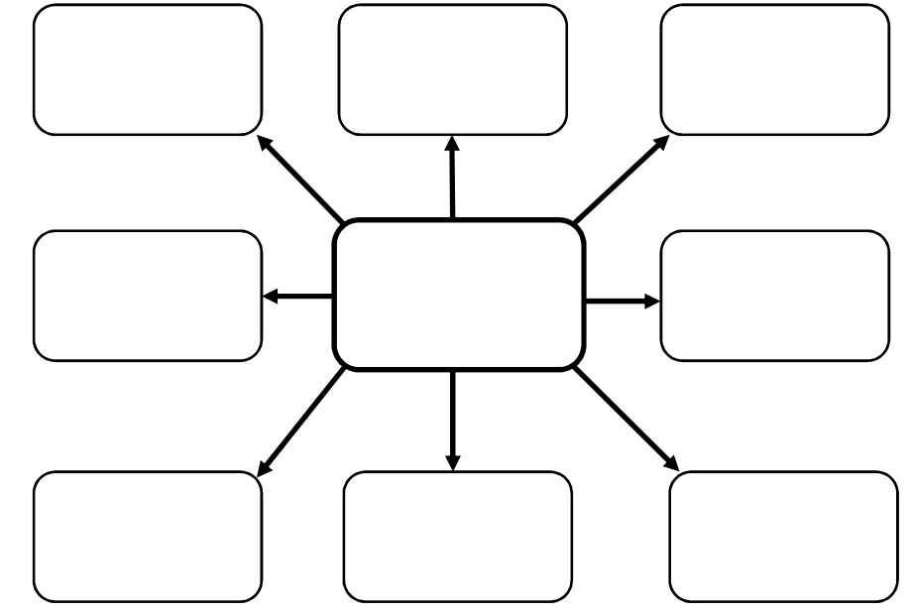

**Complete the KWL chart below**

|  |  |  |
| --- | --- | --- |
| K | W | L |
| What do you already **know** about the topic? | What do you **want** to know about the topic? | What have you **learned** about the topic? |
|  |  |  |

Define the term ***outline***: _________________________________________________________

_____________________________________________________________________________

_____________________________________________________________________________

**Key Topic 1: Rule of Law**

|  |
| --- |
| Inquiry topic/question: **Outline** what the Rule of Law is |

**Key points from information sources and reference details (5 marks)**

|  |
| --- |
|  |

**Key Topic 2: The Presumption of Innocence**

|  |
| --- |
| Inquiry topic/question: **Outline** what is the Presumption of Innocence |

**Key points from information sources and reference details (5 marks)**

|  |
| --- |
|  |

**Key Topic 3: The Burden of Proof**

|  |
| --- |
| Inquiry topic/question: **Outline** what is the Burden of Proof |

**Key points from information sources and reference details (5 marks)**

|  |
| --- |
|  |

**Key Topic 4: The Right to a Fair Trial**

|  |
| --- |
| Inquiry/question: **Outline** what is the Right to a Fair Trial |

**Key points from information sources and reference details (5 marks)**

|  |
| --- |
|  |

**Key Topic 5: The Right to Legal Representation**

|  |
| --- |
| Inquiry/question: **Outline** what is the Right to Legal Representation |

**Key points from information sources and reference details (5 marks)**

|  |
| --- |
|  |

**Complete the PMI chart below TASK**

|  |  |  |
| --- | --- | --- |
| P – Plus | M - Minus | I - Interesting |
| **Positives (Pluses)**  **about the task** | **Negatives (Minuses)**  **about the task** | **Interesting parts**  **of the task** |
|  |  |  |

**TOPIC**

|  |  |  |
| --- | --- | --- |
| P – Plus | M - Minus | I - Interesting |
| **Positives (Pluses)**  **about the topic** | **Negatives (Minuses)**  **about the topic** | **Interesting parts**  **of the topic** |
|  |  |  |

**Assessment 8: Year 7 – Civics and Citizenship Research Inquiry Task – Checklist/Marking Key**

|  |  |  |
| --- | --- | --- |
| **Assessment Task** | |  |
| **Inquiry Booklet** | **Marks Available** | **Your Marks** |
| **Description** |  |  |
| **KLW Chart – Completed KWL Chart**  Includes 5-6 key points under each heading or has used detail for at least two columns, such as ‘Want to Know and Learnt’. Uses a brief explanation for each point. | 5-6 |  |
| Includes 3-4 key points under each heading or has used some detail for at least two columns, such as ‘Want to Know and Learnt’. Uses basic detail. | 3-4 |  |
| Includes 1-2 key point under each heading. No detail provided. | 1-2 |  |
| **Subtotal** | 6 |  |
| **Description** |  |  |
| **Brainstorm – Completed Brainstorm** |  |  |
| Includes 7-8 brainstorm points inside each bubble. | 7-8 |  |
| Includes 5-6 brainstorm points inside each bubble. | 5-6 |  |
| Includes 3-4 brainstorm points inside each bubble. | 3-4 |  |
| Includes 1-2 brainstorm points inside each bubble. | 1-2 |  |
| **Subtotal** | 8 |  |
| **Description** | |  |
| **Key Topic 1: Rule of Law** | |  |
| **Outlines** five key points of information relevant to the topic | 5 |  |
| **Outlines** four key points of information relevant to the topic | 4 |  |
| **Outlines** three key points of information relevant to the topic | 3 |  |
| **Outlines** two key points of information relevant to the topic | 2 |  |
| **Outlines** one key point of information relevant to the topic | 1 |  |
| **Subtotal** | 5 |  |
| **Key Topic 2: Burden of Proof** |  |  |
| **Outlines** five key points of information relevant to the topic | 5 |  |
| **Outlines** four key points of information relevant to the topic | 4 |  |
| **Outlines** three key points of information relevant to the topic | 3 |  |
| **Outlines** two key points of information relevant to the topic | 2 |  |
| **Outlines** one key point of information relevant to the topic | 1 |  |
| **Subtotal** | 5 |  |
| **Key Topic 3: The Presumption of Innocence** |  |  |
| **Outlines** five key points of information relevant to the topic | 5 |  |
| **Outlines** four key points of information relevant to the topic | 4 |  |
| **Outlines** three key points of information relevant to the topic | 3 |  |
| **Outlines** two key points of information relevant to the topic | 2 |  |
| **Outlines** one key point of information relevant to the topic | 1 |  |
| **Subtotal** | 5 |  |
| **Key Topic 4: The Right to a Fair Trial** |  |  |
| **Outlines** five key points of information relevant to the topic | 5 |  |
| **Outlines** four key points of information relevant to the topic | 4 |  |
| **Outlines** three key points of information relevant to the topic | 3 |  |
| **Outlines** two key points of information relevant to the topic | 2 |  |
| **Outlines** one key point of information relevant to the topic | 1 |  |
| **Subtotal** | 5 |  |
| **Key Topic 5: The Right to Legal Representation** |  |  |
| **Outlines** five key points of information relevant to the topic | 5 |  |
| **Outlines** four key points of information relevant to the topic | 4 |  |
| **Outlines** three key points of information relevant to the topic | 3 |  |
| **Outlines** two key points of information relevant to the topic | 2 |  |
| **Outlines** one key point of information relevant to the topic | 1 |  |
| **Subtotal** | 5 |  |
| **Description** | |  |
| **Organisation of information and/or data** | |  |
| Organises information and/or data into clear categories using appropriate subheadings | 5-6 |  |
| Organises information and/or data into some categories using subheadings | 3-4 |  |
| Organises information and/or data in a limited fashion | 1-2 |  |
| **Subtotal** | 6 |  |
| **Description** | |  |
| **Bibliography** | |  |
| Follows correct format according to referencing technique approved by the school | 3-4 |  |
| Lists sources used | 1-2 |  |
| **Subtotal** | 4 |  |
| **Description – Evaluating and Reflecting** |  |  |
| **PMI Chart – Completed PMI Chart (Task and Topic)**  Includes 5-6 key points in total for the task (2 under each heading).  Includes 3 points for the topic (1 under each heading)  Uses a brief explanation for each point. | 5-9 |  |
| Includes 3-4 key points under each heading. Uses basic detail. | 3-4 |  |
| Includes 1-2 key point under each heading. No detail provided. | 1-2 |  |
| **Subtotal** | 6 |  |